Homework 3 Student Name: **Narahari Rahul Malayanur**

AuE 8930: Machine Perception and Intelligence

Instructor: Dr. Bing Li, Clemson University, Department of Automotive Engineering

* Refer to Syllabus for homework grading, submission and plagiarism policies;

* Submission files includes (Due Feb. 25, 2021 11:59 pm):

* This document file (with answers), and with your program results/visualization;
* A .zip file of source code (and data if any) with names indicating question number;

Note: For questions 1) and 2), you are required to write your own code rather than using any direct build-in implementation from 3rd party (like Matlab, Python, or others) libraries. You may use 3rd party built-in functions to check your results if you would like.

Question 1)

[Sampling/2D-Convolution – 15 pts] Download the image “[Lenna.jpg](https://www.dropbox.com/s/wugkfgmni8424pj/Lenna.jpg?dl=0)” from the hyperlink.

(Lenna or Lena image is a standard test image widely used for image processing since 1973.)

* 1. Convert the image from RGB to gray, using a standard RGB-intensity conversion approach like NTSC, and store the converted image “LennaGray.jpg” as an 8-bit gray image. (2 pts)

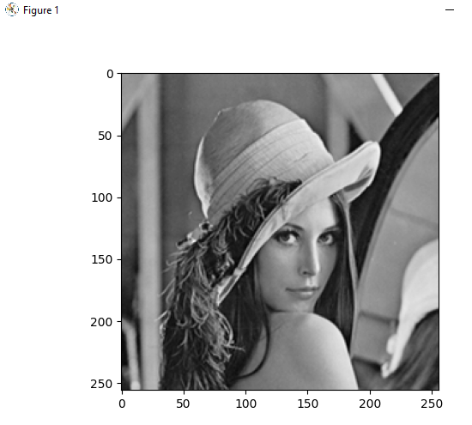

* 1. Down-sampling image “LennaGray.jpg” from size 256x256 to 64x64. (3 pts)

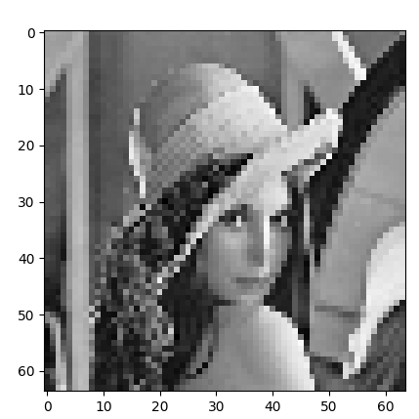

Perform the down-sampling and visualize your result.

1-3) Implement the convolution (using basic arithmetic operations only, rather than build-in conv()) of Sobel kernel on the “LennaGray.jpg” for edge detection, visualize and comment your detection result. (10 pts)

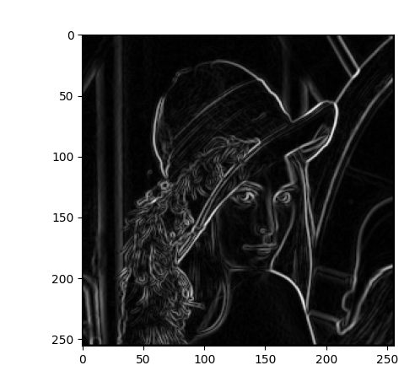

**Comments:**

I have applied both the vertical and horizontal 3 x 3 Sobel kernel on the image and after applying it I have taken the square root of the sum of the squares of the image array. This result is capturing both the horizontal and vertical edges in image while the remaining things are made darker.

Question 2)

[Histogram Equalization – 15 pts.] Take the converted gray image “LennaGray.jpg”.

2-1) Perform histogram analysis and visualize histogram distribution (2 pts);

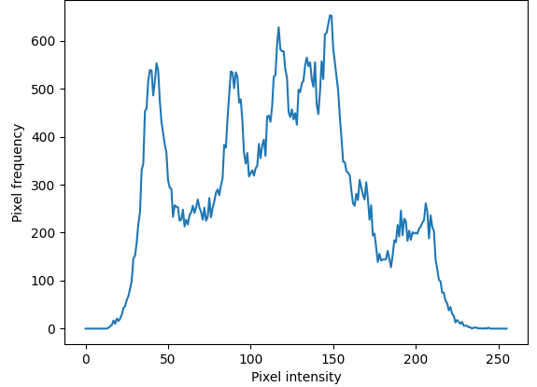

2-2) Calculate and visualize accumulative histogram distribution (3 pts);

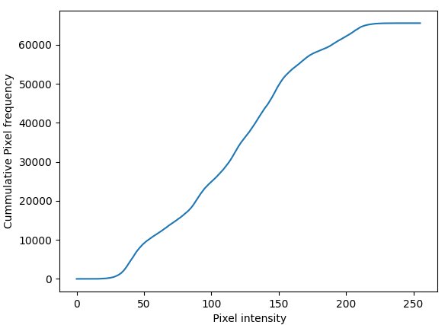

2-3) Implement a function to perform histogram equalization for this image, visualize your histogram-equalized image and its histogram distribution. Comments the difference between the two images before/after histogram equalization. (10 pts);

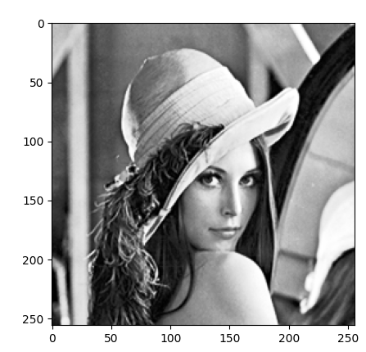 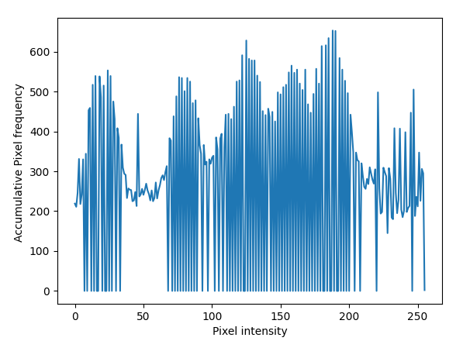

**Comments:**

The histogram as it can be seen before the performing the histogram equalization, it is has peaks around 100 – 150 level. After doing the histogram equalization the the gray scale intensity is more evenly spread and as it can be seen the histogram has more peaks than it had previously. The image is more contrast and has more shaprness after doing the histogram equalization than before.

Question 3)

[Line Detection – 30 pts] Download the image “[ParkingLot.jpg](https://www.dropbox.com/s/dawhrd4g3xyk07g/ParkingLot.jpg?dl=0)” from the hyperlink.

Note: For this question, you are free to use any 3rd party libraries.

3-1) Apply and visualize histogram analysis, then find a proper threshold to convert the image to a binary image. (2 pts)

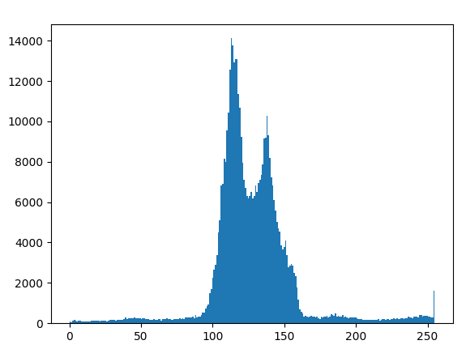

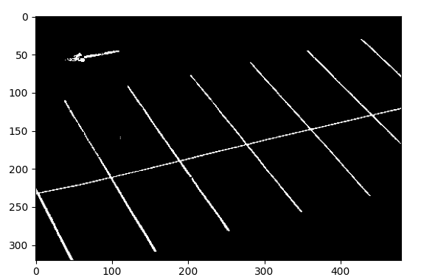

3-2) Apply Hough transformation or other line detection approach to detect multiple lines in the image (You select a threshold for the voting matrix). Visualize the lines in the image space and in the transformed space (like Polar space) respectively. (5 pts)

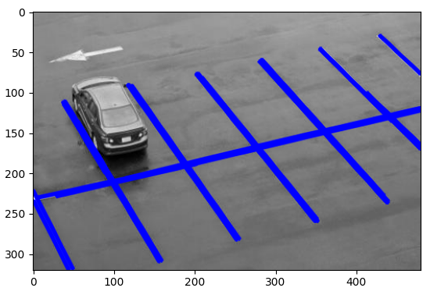

3-3) Comment on: will the two lines as two sides of a particular park space be parallel or not, explain why? (3 pts)

In real life, these parallel parking space lines will be parallel but in this camera image it is not parallel. One of the reasons for these lines not to be parallel because of the translation and rotation transformation. Also, it could be due to the improper calibration of the camera with the extrinsic parameters.

3-4) Design and implement the approaches to find all parking space polygons with the four vertex points for each parking space. Describe your approaches and visualize all detected polygons with different colors overlaid on the original image. The TA will check your code. (20 pts)

Approach:

1. Using the canny edge detection, we shall find the edges in the image by first converting into a gray scale.
2. After applying canny edge filter, we can find the Hough lines by using the Hough transformation using the edges found by the canny edge detection function.
3. By using these hough lines along with certain conditions we can find the end points of the parallel lines in the parking spot.
4. Here in the image below, by using those end points, the mid points can be calculated and thereby the vertices of the parking space can be found out.
5. In the image, I haven’t considered the other spots because the lines in the image are incomplete. 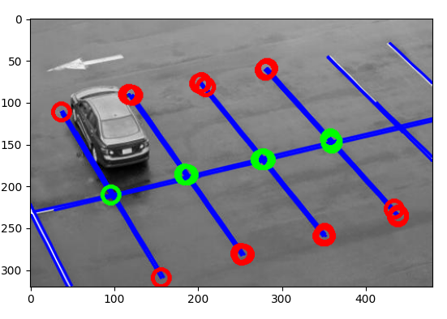
6. After finding the intersection, we can draw the rectangle based on the these four points of intersection.

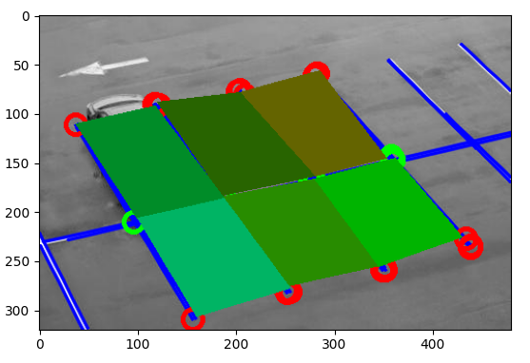

Question 4)

[Survey – 40 pts] Write a 2~3 pages survey report on a specific 2D-data measurement/detection problem related to automotive engineering.

* Please targeting at a specific 2D-detection goal/object. e.g.: lane detection, traffic sign detection, pedestrian detection, drivable area detection, a B-scan inspection for a manufacturing component, material characterization using microscopy image, et al. It is not limited to camera data.
* The detection target needs to be specific, rather than generic such as ‘Obstacle’ since it is not a specific target.

The grading of this question is based on the contents in the aspects of:

- The importance of measuring this target (5);

- The challenges of measuring this target (5);

- Existing approaches of measuring this target (15);

- Existing problems of these existing approaches (10);

- There will be other grading factors (such as novelty, organization, et al) (5);

* Attention: You are encouraged to include any drawing/table in the report;

* This survey is more focusing for the sensing and measurement of a 2D physical quantity or object, rather than comparing multiple 2D sensing modalities.

* You should not literally copy sentences from reference, and use “…” [1] to mark it if you really have to literally cite few sentences. For citations, use brackets （e.g. [1]) in the end of your statements, with reference list in the end of the report.

**Topic: Lane Detection:**

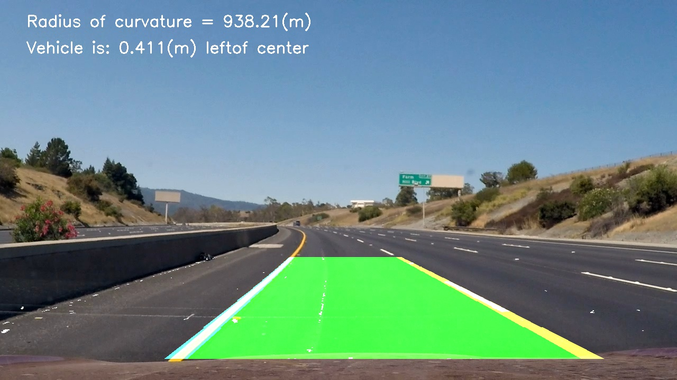

Figure : Source google images

**The importance of measuring this target (5):**

Lane keeping is one of the most basic components that is required for safe driving even for human driver. Therefore, when vehicles start to become autonomous, lane keeping is one of the most basic functions that the intelligent system should carry out. The autonomous system must be able to detect and localize lanes from the visual/road image. Recent fast commercial lane-detection systems are available and show good performance in challenging road conditions. This lane detection system can be implemented to carry out many other driver assistant functions in the self-driving system like lane crossing warnings, lane keeping, etc.

The lane detection technique enables vehicle to detect lanes and avoid collisions and also acts as a warning system if vehicle passes boundaries of the lane [1]. There is significant work in the field of machine learning and computer vision in regard to lane detection. This has prominent application in intelligent vehicle systems as well. “The lane detection system comes from lane markers in a complex environment and is used to estimate the vehicle’s position and trajectory relative to the lane reliably” [2]**.**

**The challenges of measuring this target (5):**

“Getting lane curvature system is difficult. For instance, a false alarm can be generated by the collision warning system when the lane curvature is unknown or when it cannot differentiate between objects on the sidewalk and objects on the road” [4].

• Lane boundaries are not clearly visible due to the following factors.

• **Color Fade:** The fading of lane markings is also a significant challenge for the camera to detect the continuous lane.

**• Weather conditions**: The dynamic weather conditions pose a difficulty for the cameras to detection the lanes as the edge detection becomes significantly complex due to the change in the reflective index while image processing.

• Lighting conditions: The lighting conditions during nighttime detection are an important factor to consider as the detection becomes challenging without any secondary support of night vision technology.

• “All these factors can make the make it difficult for the visual systems to differentiate between lane and the background of image” [5].

• High speed traffic and unpredictable road traffic environments/conditions.

**Existing approaches of measuring this target (15):**

• The lane detection task is mainly divided into two steps: edge detection and line detection. Primarily the image is captured using the on-board vehicle cameras. This image is processed for edge detection using techniques like sobel operator and finally the lines are isolated using hough transformation.

• As an alternative to a vision-based approach, one may use a global-positioning system (GPS) with a geographic information system (GIS). However, the GPS has a limitation on the spatial and temporal resolution, and detailed information is often missing or not updated frequently in GIS [4].

• “Modern machine learning methods can be used to identify the features that are rich in recognition and have achieved success in feature detection tests. However, these methods have not been fully implemented in the efficiency and accuracy of lane detection. In this paper, we propose a new method to solve it. We introduce a new method of preprocessing and ROI selection. The main goal is to use the HSV color transformation to extract the white features and add preliminary edge feature detection in the preprocessing stage and then select ROI on the basis of the proposed preprocessing. This new preprocessing method is used to detect the lane. By using the standard KITTI road database to evaluate the proposed method, the results obtained are superior to the existing preprocessing and ROI selection techniques.” [3]

**Existing problems of these approaches (10):**

• “Detecting edges is an important problem in many areas of applications and is one of the most important problems in image analysis. Although the performance of most of these detectors is acceptable for simple noise free images, the case is dramatically different for images of real scenes, contaminated with noise” [6]

• “The GPS has a limitation on the spatial and temporal resolution, and detailed information is often missing or not updated frequently in GIS. For example, it is important to detect the road curvature at an off-ramp because it can generate a false-collision warning, but most GPS-based systems suffer from even discriminating whether the vehicle entered an off-ramp or not” [4].

• “The new edge could be obtained with the proposed method. Mu and Ma proposed Sobel edge operator which can be applied to adaptive area of interest (ROI) [11]. However, there are still some false edges after edge detection. These errors will affect the subsequent lane detection. Wang et al. proposed a Canny edge detection algorithm for feature extraction [12]. The algorithm provides an accurate fit to lane lines and could be adaptive to complicated road environment. In 2014, Srivastava et al. proposed that the improvements to the Canny edge detection can effectively deal with various noises in the road environment [13]. Sobel and Canny edge operator are the most commonly used and effective methods for edge detection” [3].

**References:**

**[1]** Hoang TM, Hong HG, Vokhidov H, Park KR. Road Lane Detection by Discriminating Dashed and Solid Road Lanes Using a Visible Light Camera Sensor. *Sensors (Basel)*. 2016;16(8):1313. Published 2016 Aug 18.

**[2]** Y. Saito, M. Itoh, and T. Inagaki, “Driver Assistance System with a Dual Control Scheme: Effectiveness of Identifying Driver Drowsiness and Preventing Lane Departure Accidents,” *IEEE Transactions on Human-Machine Systems*, vol. 46, no. 5, pp. 660–671, 2016.

**[3]** Mingfa Li, Yuanyuan Li, and Min Jiang Lane Detection Based on Connection of Various Feature Extraction Methods. Department of Electronic and Electrical Engineering, Shanghai University of Engineering Science, Shanghai, China. 07 Aug 2018

**[4]** Z. Kim, "Robust Lane Detection and Tracking in Challenging Scenarios," in *IEEE Transactions on Intelligent Transportation Systems*, vol. 9, no. 1, pp. 16-26, March 2008.

**[5]** Hoang TM, Hong HG, Vokhidov H, Park KR. Road Lane Detection by Discriminating Dashed and Solid Road Lanes Using a Visible Light Camera Sensor. *Sensors (Basel)*. 2016;16(8):1313. Published 2016 Aug 18. doi:10.3390/s16081313

**[6]** M. Bennamoun, "Edge detection: problems and solutions," *1997 IEEE International Conference on Systems, Man, and Cybernetics. Computational Cybernetics and Simulation*, Orlando, FL, USA, 1997, pp. 3164-3169 vol.4.